**Project -1**

**Task-1**

**INPUT FILE-**

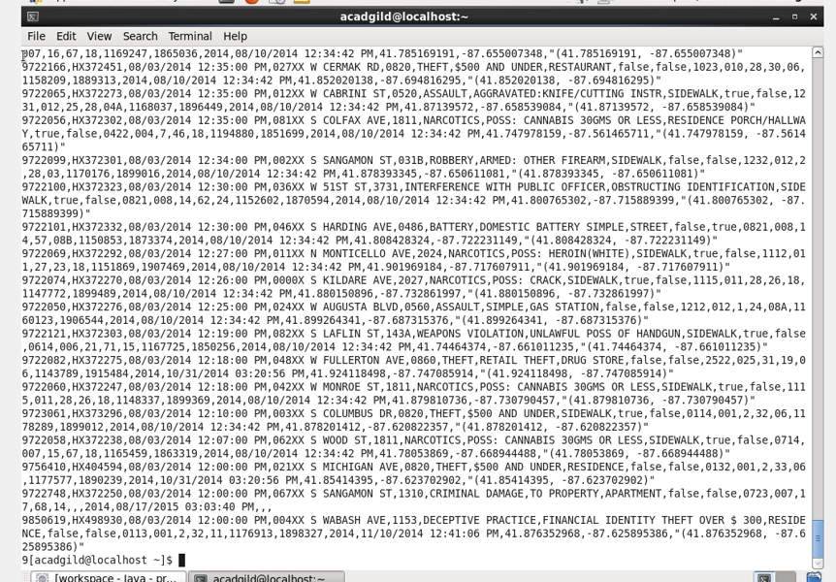

**SOLUTIONS BY PIG-**

1. **Write a mapreduce and pig program to calculate the number of cases investigated under each FBI code.**

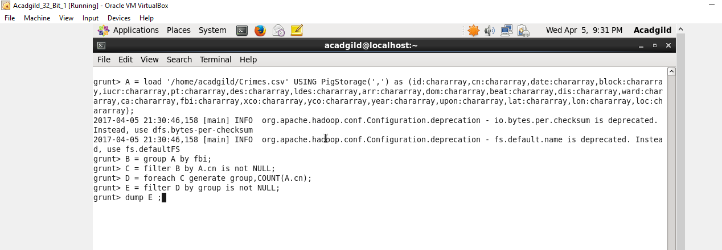

**OUTPUT –**

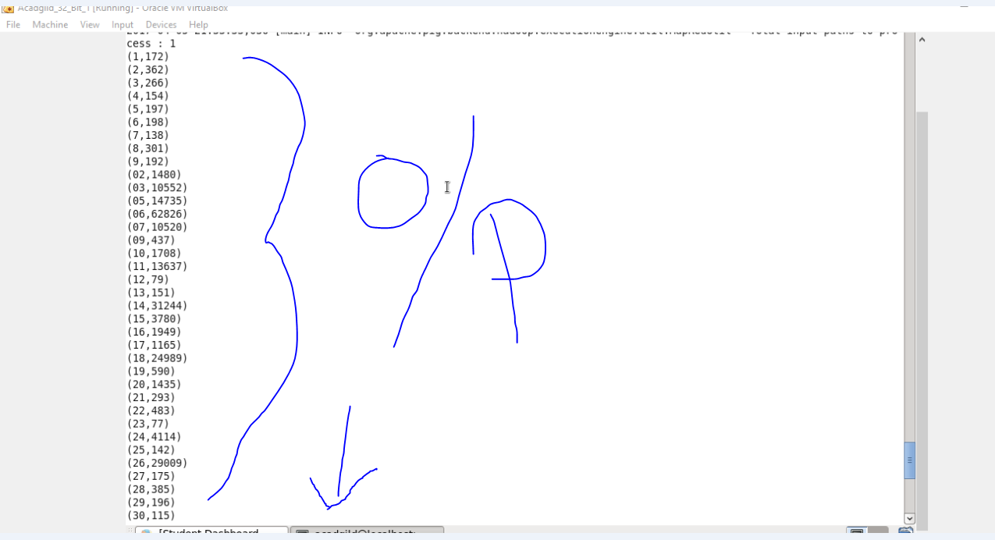

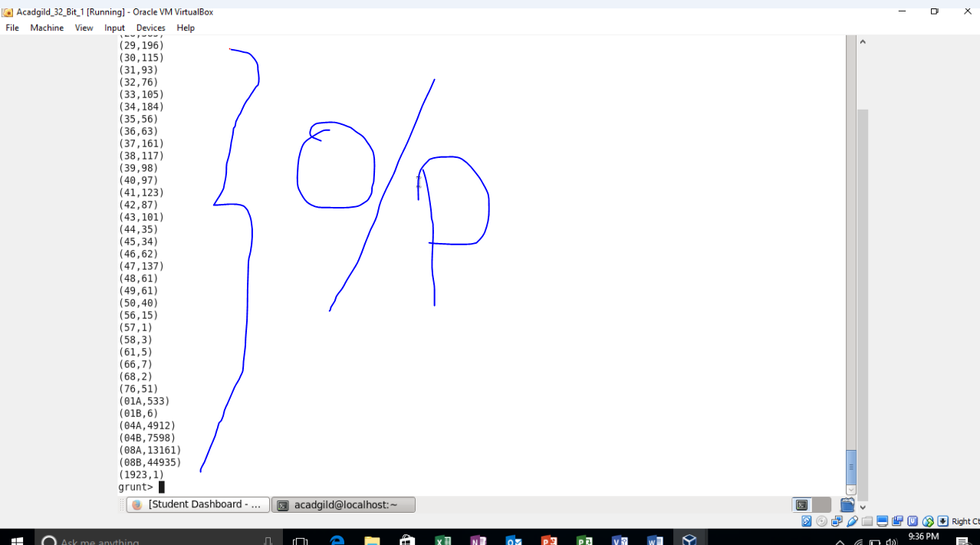

1. **Write a mapreduce and pig program to calculate the number of cases investigated under FBI code 32.**

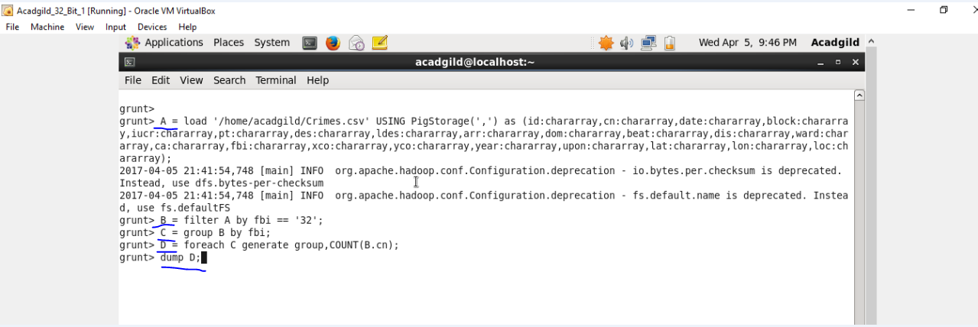

**Output-**

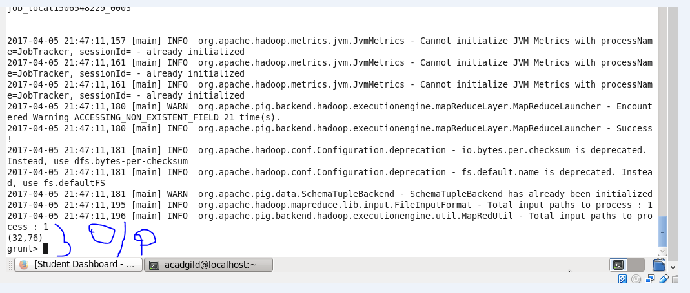

1. **Write a mapreduce and pig program to calculate the number of arrests in theft district wise.**

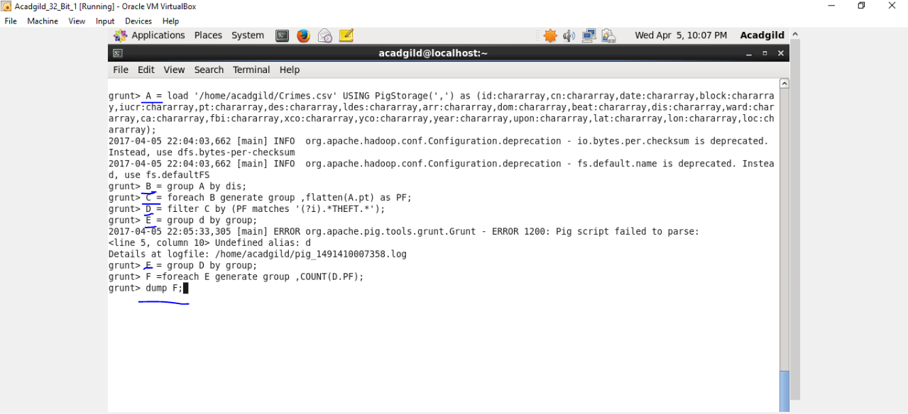

**Output-**

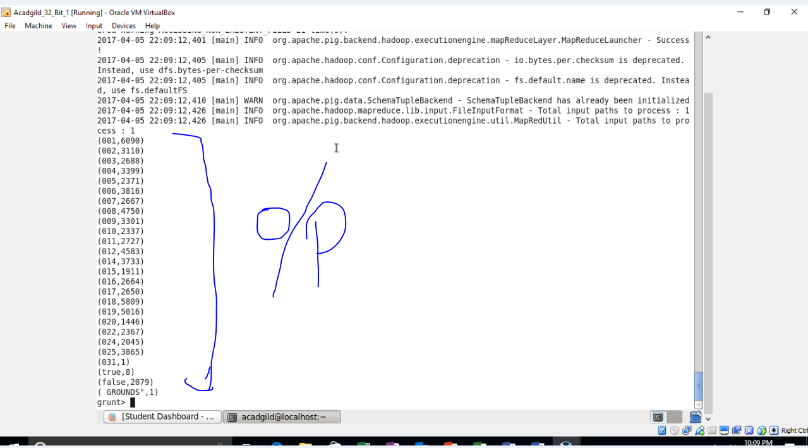

1. **Write a mapreduce and pig program to calculate the number of arrests done between October 2014 and October 2015.**

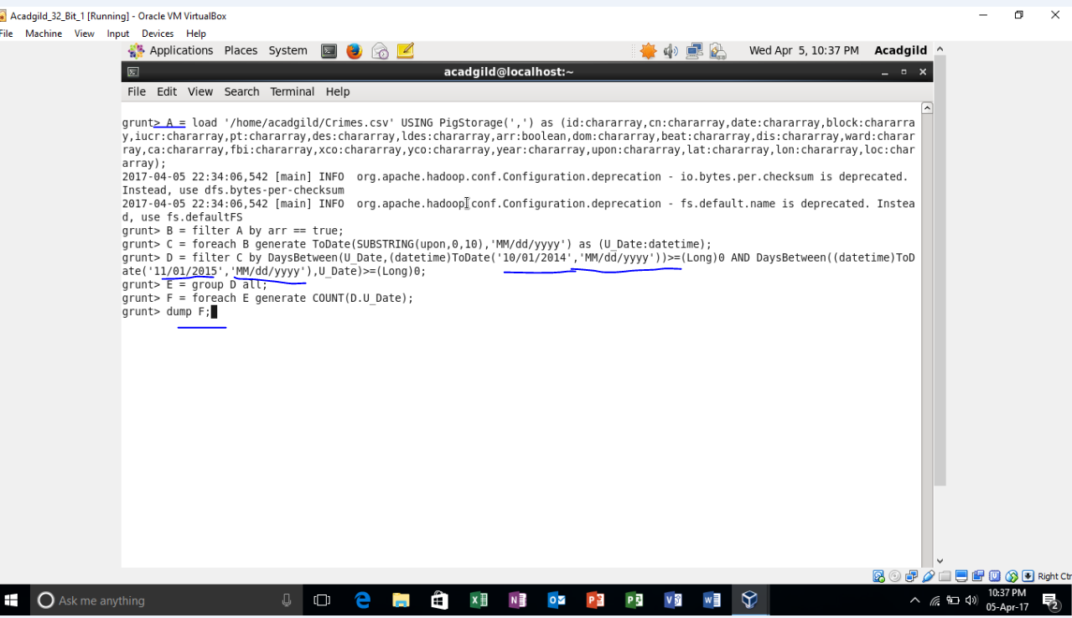

**Output-**

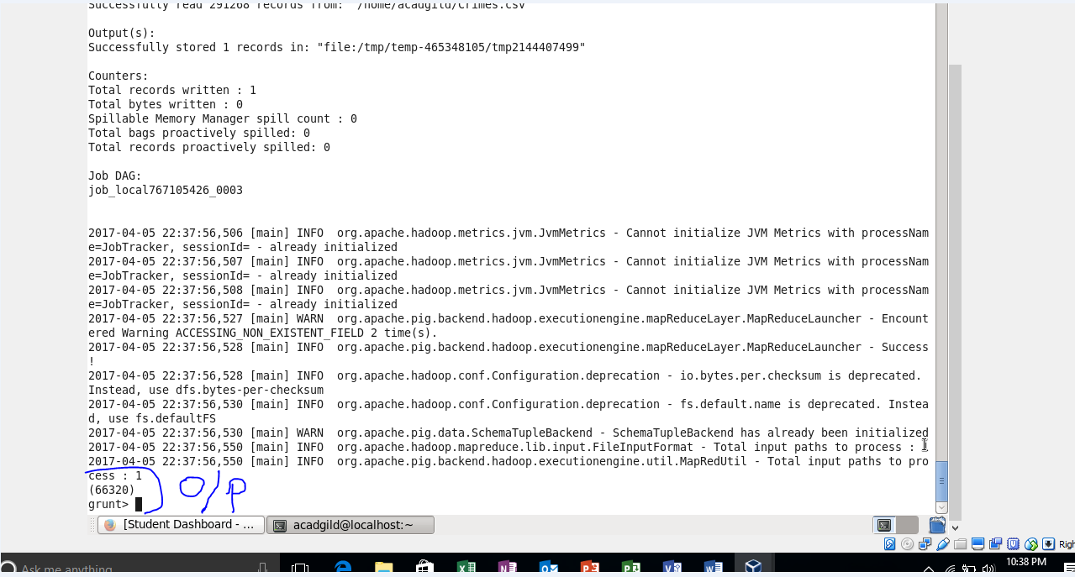

**SOLUTION BY MAP REDUCE-**

1. **Write a mapreduce and pig program to calculate the number of cases investigated under each FBI code**

**DRIVER-**

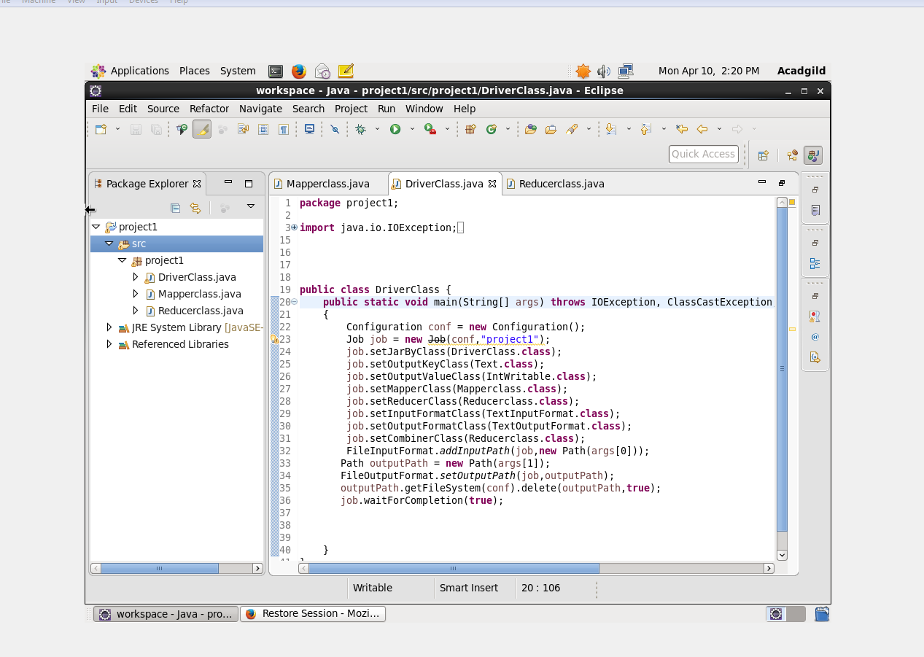

**REDUCER-**

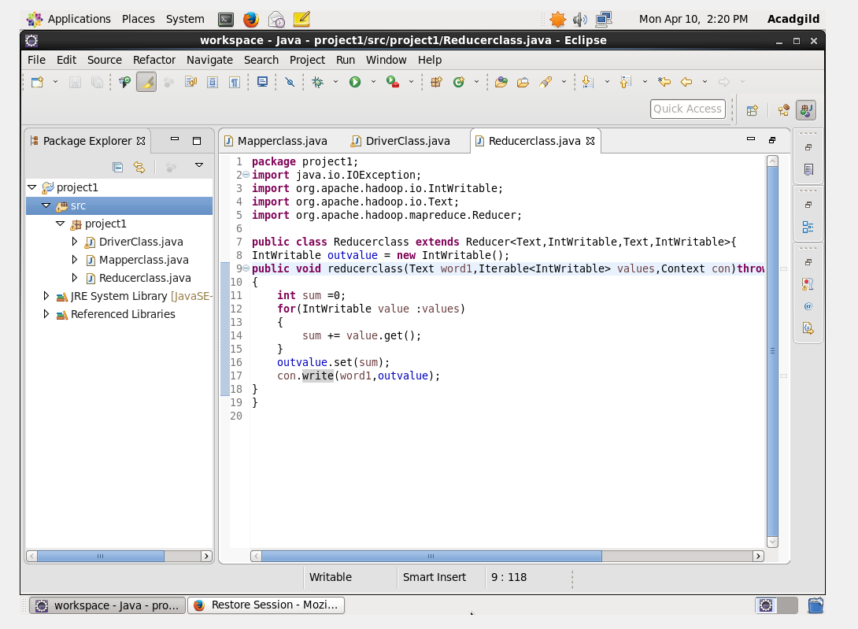

**MAPPER-**

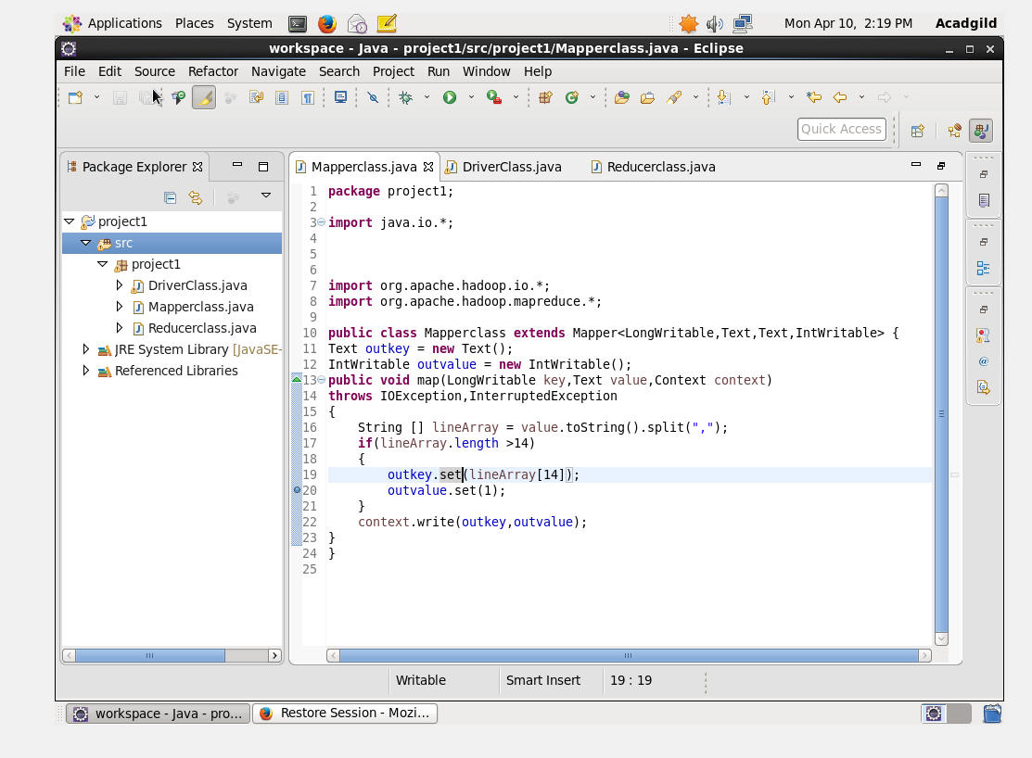

**OUTPUT-**

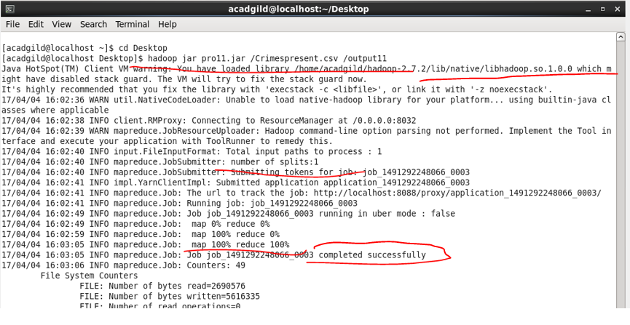

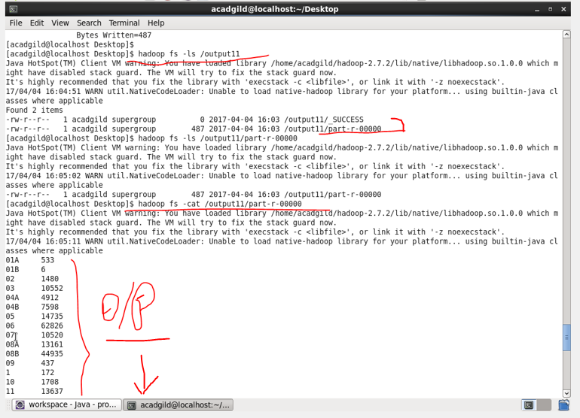

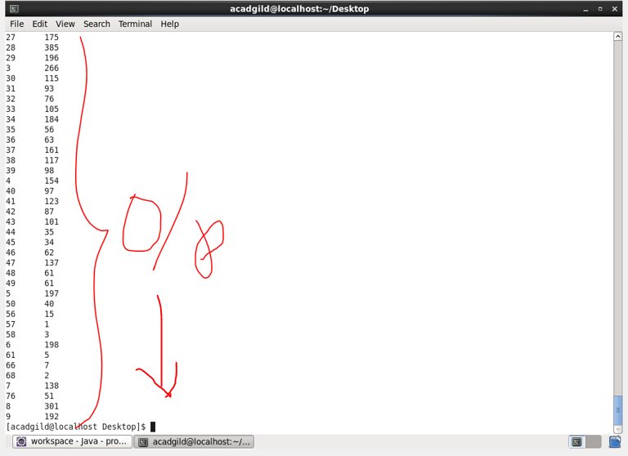

1. **Write a mapreduce and pig program to calculate the number of cases investigated under FBI code 32.**

**DRIVER-**



**REDUCER-**



**MAPPER-**

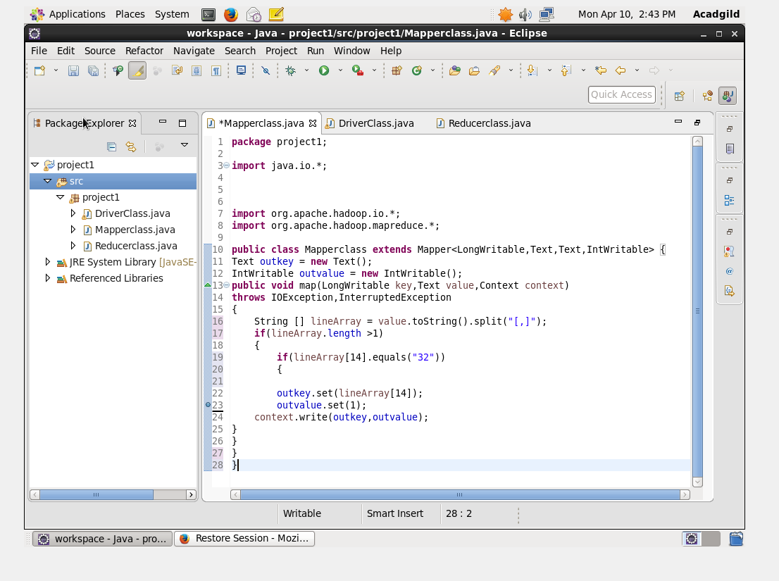

**OUTPUT-**

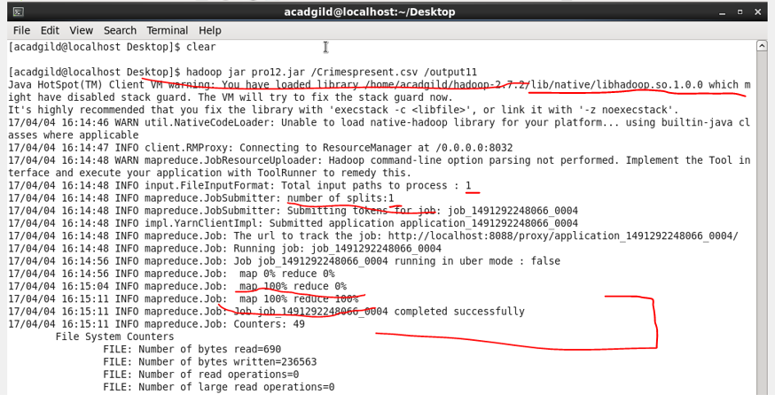

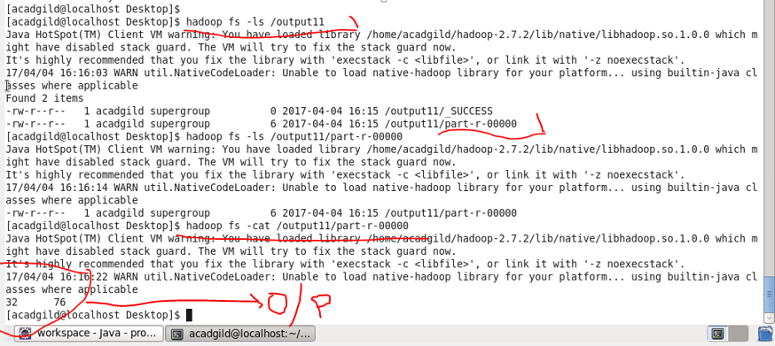

1. **Write a mapreduce and pig program to calculate the number of arrests in theft district wise.**

**DRIVER-**



**REDUCER-**



**MAPPER-**

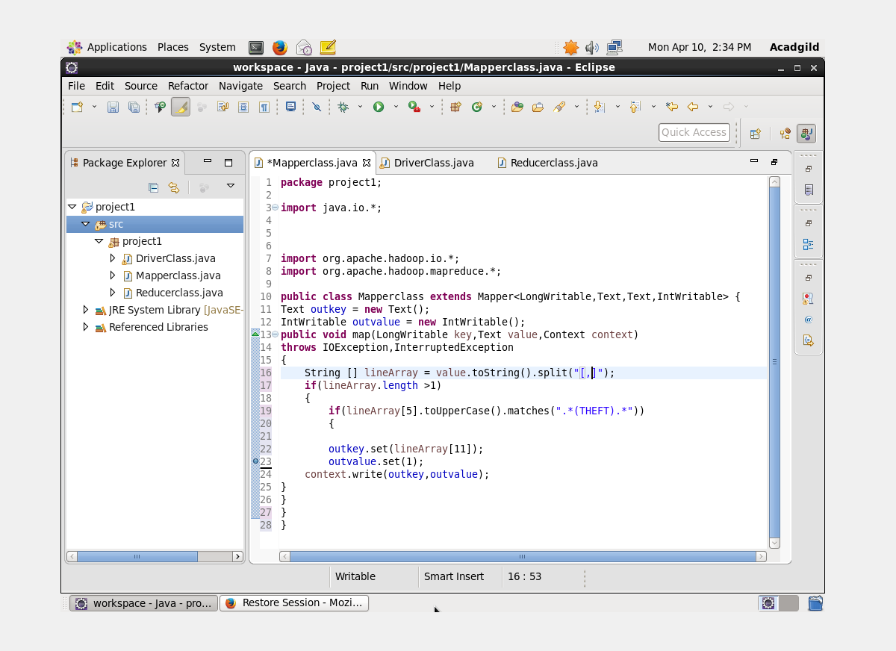

**OUTPUT-**

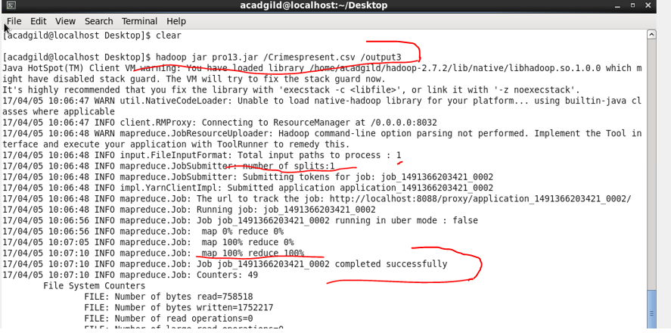

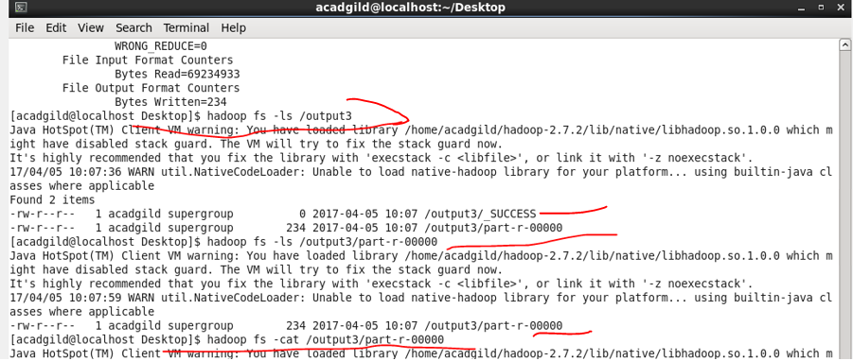

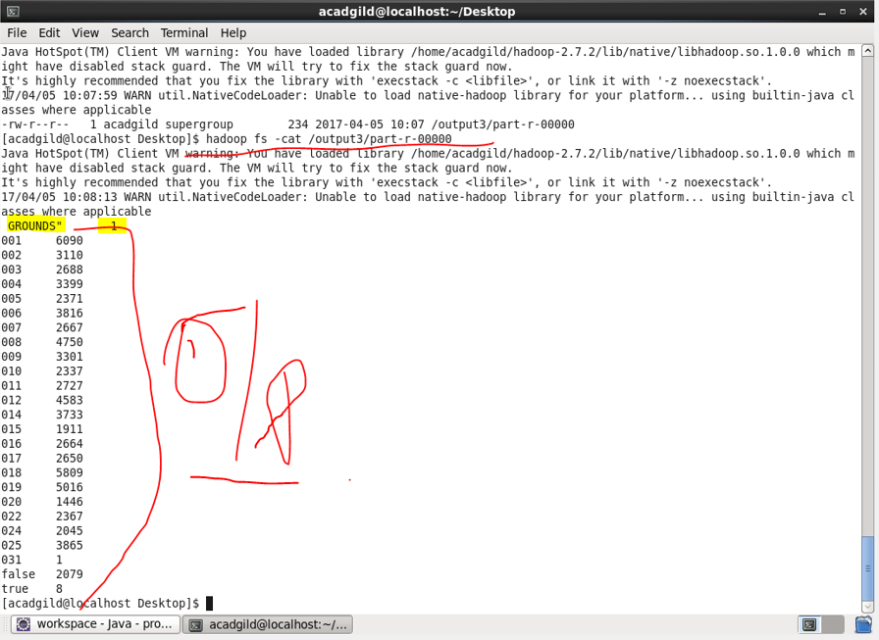

1. **Write a mapreduce and pig program to calculate the number of arrests done between October 2014 and October 2015.**

**DRIVER-**



**REDUCER-**



**MAPPER-**

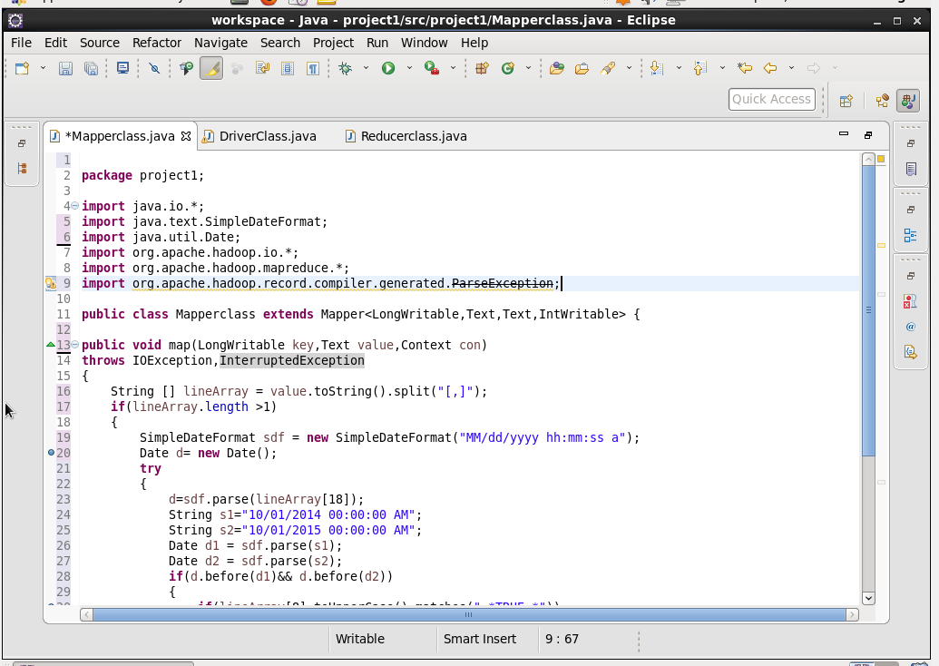

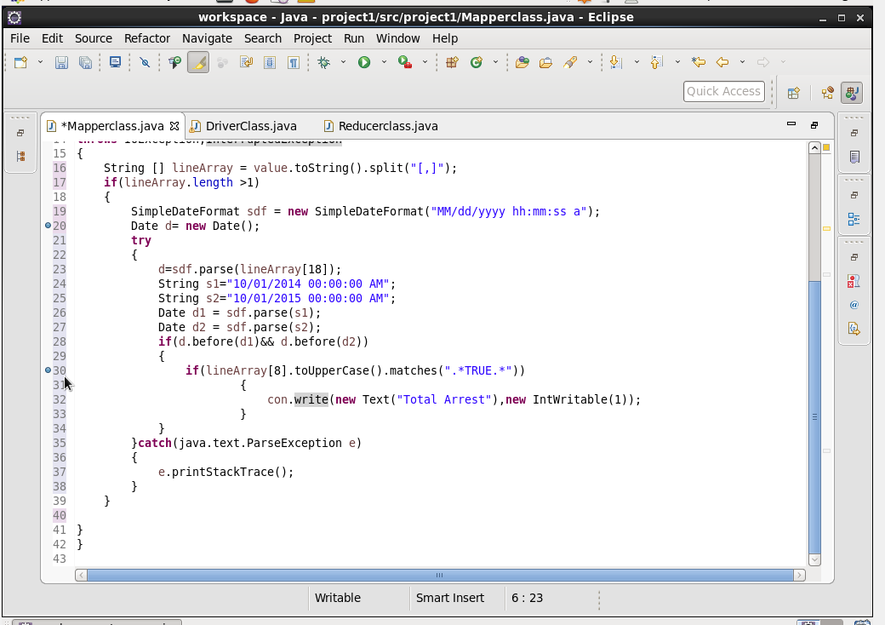

**OUTPUT-**

